Training and Testing sets: Documentation on size and composition

80% of the telecom customer churn dataset will be used for training, while the remaining 20% will be used for testing. This enables the machine learning models to be assessed using independent, unseen testing data after they have learned patterns from the training data.

A detailed explanation of my code's functions, the significance of each step, and the files it generates will be found below.

1. Dataset splitting

The train_test_split() function in Scikit-learn was used to separate the dataset into training and testing sets once it had been cleaned, its quality checked, categorical variables converted into numerical values, and the churn goal variable prepared.

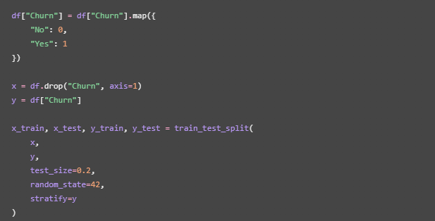

Explanation:
- Target variable: The Churn column was transformed into numerical values for the target variable. 0 stood for "no," and 1 for "yes." Because of this, machine learning algorithms can use the target variable.
- Independent variables (x): Every column was chosen as an input feature, with the exception of Churn.
- Dependent variable (y): The goal variable that the model will forecast is the Churn column.
- Training set (80%): Used to help machine learning models learn patterns related to customer attrition.
- Testing set (20%): Used to assess the trained models' performance on untested data.
- Random state (42): When the code is run with the identical input data, random state (42) guaranties that the dataset is divided consistently.
- Stratification: In both datasets, the stratify=y parameter preserves roughly the same percentage of consumers who churned and those who did not. This is significant because there may be an imbalance between the two classifications in churn datasets.

2. Training and testing dataset composition

The dataset was divided into two separate groups:

Dataset | Percentage | Purpose
Training set | 80% | Used to train the machine learning models
Testing set | 20% | Used to evaluate model performance

The input features are the same in both datasets. They do, however, have distinct client records.

The goal variable and the input features are kept apart:

- X_train.csv: Input features for training.
- Y_train.csv: Actual churn labels for training.
- X_test.csv: Input features for testing.
- Y_test.csv: Actual churn labels for testing.

Because of this division, the machine learning algorithms can use the relevant churn status as the expected result and customer information as the input.

3. Feature Scaling

StandardScaler was used to standardize numerical features prior to model training.

The numerical columns selected for scaling were:

- SeniorCitizen
- Tenure
- MonthlyCharges

Numerical numbers are transformed via standardization to roughly have a mean of 0 and a standard deviation of 1.

The formula is:
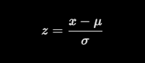

Where:
- x = original value
- μ = mean of the feature
- 𝝈 = standard deviation of the feature
- z = standardised value

After scaling the entire dataset, my code fits the scaler once more using just the training set and applies it to the testing set:

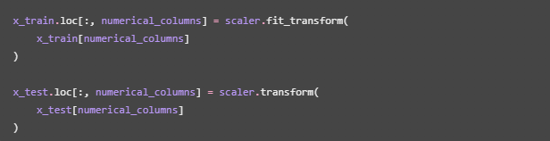

For model training, the second scaling procedure is crucial. Only the training data is used to generate the mean and standard deviation, which are then applied to the testing data. This aids in preventing test set data from affecting the model development scaling.

4. Exporting the training and testing files

After splitting and scaling, the four datasets were saved as separate CSV files.
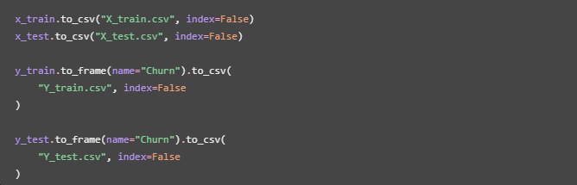
The purpose of each file is explained below:

File name | Contents | Purpose
X_train.csv | 80% of customer input features | Used as input when training the models
Y_train.csv | Churn labels for the training records | Provides the correct churn status during training
X_test.csv | 20% of customer input features | Used as input when evaluating the models
Y_test.csv | Churn labels for the testing records | Provides the actual churn status for comparison with predictions

The index=False parameter prevents Pandas from adding an extra index column to the exported CSV files.

5. Training and testing summary

To document the size and composition of both datasets, a summary table was generated using Pandas.

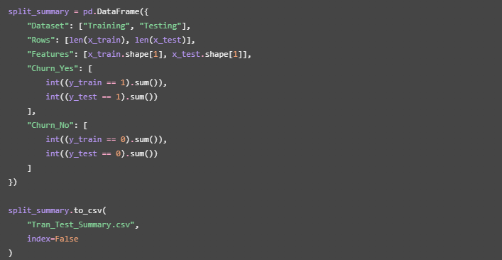

This summary records:

- Dataset: Determines if the records are part of the testing or training set.
- Rows: Displays each dataset's total number of client records.
- Features: Indicates how many input columns the machine learning models can use.
- Churn_Yes: Counts clients who stopped using the service.
- Churn_No: Takes into account clients who kept utilizing the service.

The summary file makes it easier for the project team to understand the size and class composition of the training and testing datasets.

8. Overall outcome

The Customer Churn Analysis project's subsequent phases were supported by the training and testing datasets. Categorical variables were encoded, duplicate records were eliminated, the original dataset was cleansed, and the churn target variable was transformed into numerical format.

After that, stratified sampling was used to split the dataset into an 80% training set and a 20% testing set. StandardScaler was used to standardize numerical characteristics; the scaler was fitted to the training data and then applied to the testing data.

In order to record the quantity of entries, features, and churn categories in each set, a summary file was created once the datasets were exported into distinct CSV files.

The project team can now use these generated datasets for machine learning tasks, such as Artificial Neural Network (ANN) churn prediction and K-Means customer segmentation.

